

Land Offering

St George Airport East Development Block

Total Available Acreage: 538.36 ± Acres

Parcel 1: 485.10 ± Acres
Washington City, Utah

Parcel 2: 53.26 ± Acres
St George City, Utah

LOCATION & PROPERTY DESCRIPTION

LOCATION

The St. George Airport East Development Block is located on the east side of the St. George Regional Airport. These lands border the Alaia Development (formerly Stucki Farms) to the north, BLM lands to the east and the ARA Southwest Logistics Development to the south. The majority of the parcel (designated as Parcel 1) resides within the municipal boundaries of Washington City, with a 53.26-acre parcel (designated as Parcel 2) residing within the municipality of St. George City. Legally, the parcel resides within Township 43 South, Range 15 West SLB&M, within sections 13, 14, and 24 (see Exhibit A).

DESCRIPTION

The property is approximately 538.36 acres (based on GIS data) and is currently ungraded, raw land in its natural state. The terrain is mostly flat with small hills and natural washes throughout. The property offers unobstructed views of the St. George Metropolitan Area and Pine Valley Mountain to the north, and Warner Ridge to the east.

Note: A formal legal description for this block has not yet been written. The successful bidder(s) will be required to provide this description.

ENTITLEMENTS

The developer(s) will be required to collaborate with either or both Washington City and St. George City to establish development use plans acceptable to the municipalities. The current municipal land use plans are designated as follows:

- Washington City: General Plan designates the block as Community Commercial, Regional Commercial, and Industrial. Current zoning is General Commercial C-3.

- St. George City: General Plan designates the block as Airport (A). Current zoning is Airport Supporting Business Park (ASBP).

UTILITIES

- Water, Sewer, & Gas: Are located in Washington Fields Road, which runs through and along the western border of the property.
- Power: Active power lines are adjacent to both the northern and southern borders of the property. Additionally, a power transmission line with sufficient capacity for full parcel development runs along 4700 E, bordering the eastern edge of the property.

IMPROVEMENTS

State Route 7 (SR-7 / Southern Parkway): Runs directly through the property. Two planned interchanges within the block boundaries—Exit #8 and Exit #9—have not yet been constructed.
Washington Fields Road: A 106-foot Major Arterial Road that runs through and along the western border of the property.

EASEMENTS

The property is encumbered by two perpetual easements (see Exhibit B):

- Easement 1976: An 89.12-acre Utah Department of Transportation (UDOT) perpetual Right-of-Way easement for SR-7 and the proposed Exit #9.
- Easement 1972: A 78.65-acre Flood Control Easement issued to the St. George and Washington Canal Company for a flood control basin.
  - For Easement 1972 TLA would encourage interested parties to examine these lands and present proposals that could use the lands in their current state or to study the viability of piping the basin.

PROPERTY CONDITION

The St George Airport East Development Block is mostly ungraded in a natural, raw condition.

CULTURAL CLEARANCE

The successful bidder will be required to retain Trust Lands Administration (TLA) approved consultants to inventory, document, and ultimately protect, avoid, or mitigate any cultural resources discovered on the property.

OFFER INFORMATION

Proposals may be submitted on the full development block or on Parcel 1 or Parcel 2.

For those parties interested in submitting an offer, the following
elements should be included in your proposals.

- Cash offer price and closing terms; OR Revenue sharing terms (development partner gets X% of gross lot/finished structure sales, TLA gets Y% of gross lot/finished structure sales).
- Subdivision layout & community vision showing minimum number of lots,
location and size of amenities, parks, trails, etc.
- Funding mechanisms for development must be clearly identified.
- Financial pro-forma for the development including absorption, phasing
plans, minimum lot/finished structure prices for all product types and models (TLA will
consider proposals of developed lots only, finished development structures only, or a
combination of both).
- Identification of key officers of the company
- Term of inspection period, if needed
- Contingencies, if any
- Notification address
- Marketing strategy

If a partner is selected, a development contract will include milestones and minimums
derived from the proposals. If milestones and minimums are not substantially met as
proposed, TLA will be able to terminate the contract, regardless of ongoing expenses that
the development partner might have.

CONTACT INFORMATION:

For further information or to schedule a tour of the property, please contact the
following persons:

Aaron Langston,
Assisting Managing Director
1593 Grapevine Crossing Road
Washington, UT 84780
(435) 522-7411
aaronlangston@utah.gov

St George Airport East Development Block – Advertisement Proposal Details

St George Airport East Development Block

SUBMIT Sealed PROPOSALS TO: | TLA  ATTN: Aaron Langston
ADDRESS: | 1593 Grapevine Crossing Road  Washington City, UT 84780
CLOSING FOR SUBMITTAL OF PROPOSALS: | Friday October 30, 2026
ANTICIPATED BOARD APPROVAL: | March 2027
FURTHER INFORMATION: | Aaron Langston  At above address  (435) 522-7412  aaronlangston@utah.gov

TLA reserves the right to reject any or all proposals.

Information for Potential Bidders

Proposals
Development Proposals: TLA requests Development proposals for the property known as the St George Airport East development block. The Trust may enter into negotiations with one or more parties submitting proposals, or may reject all proposals.

Form: Each development proposal shall be submitted in a sealed envelope bearing the words “St George Airport East”. Proposals must be marked on the outside with the name of the respondent, their address, and telephone number. All proposals must be made on the required form. All blank spaces for pricing must be filled in, in ink or typewritten, and the proposal form must be fully completed and executed when submitted. Include additional information such as renderings, business plans, phasing, anticipated absorption rates, etc. with the proposal forms. All proposals will be designated as confidential documents.

Signatures: All proposals shall be signed and have the full address written in the appropriate spaces.

Withdrawal: Any proposal may be withdrawn any time prior to the scheduled proposal closing time.

Opening: Proposals will not be publicly opened.

Proposed compensation structure: Proposals for transaction may include:

1-) Development Lease. Trust Lands Administration’s contribution to a development lease will be the subject lands. Development Partner expected to share proformas, profit sharing, anticipated construction costs, anticipated sales prices, percentage splits, anticipated absorption rates, etc. Development Partner can propose either lot creation and vertical home building packages, or bulk wholesale lot sales to select builders. Minimum returns to the Trust must be guaranteed. The Trust does not subordinate; under no circumstance will the Trust authorize loans or liens on or against its lands.

2-) Direct Sale. Purchaser to provide total price for the subject lands. Purchasing the land in a phased take down may be considered, but proposals should outline what triggers the next take down (percentage complete, hard dates, etc.). In addition, under that scenario, an escalator for the unpurchased property must be defined.

Proposal Form

Proposal is submitted to: TLA, Attn: Aaron Langston
1593 Grapevine Crossing Road
Washington, UT 84780

Date: ____________________________________________

Business Name: ____________________________________________

Respondent Name: ____________________________________________

Title: ____________________________________________

Business Address: ____________________________________________

Telephone: ____________________________________________

Email Address: ____________________________________________

Signature(s) ____________________________________________

____________________________________________

Submitters may use the table above, or their own form if more details are needed.

Exhibit A
St George Airport East Development Block Location
Parcels 1 & 2 – Total Acerage 538.36 Acres
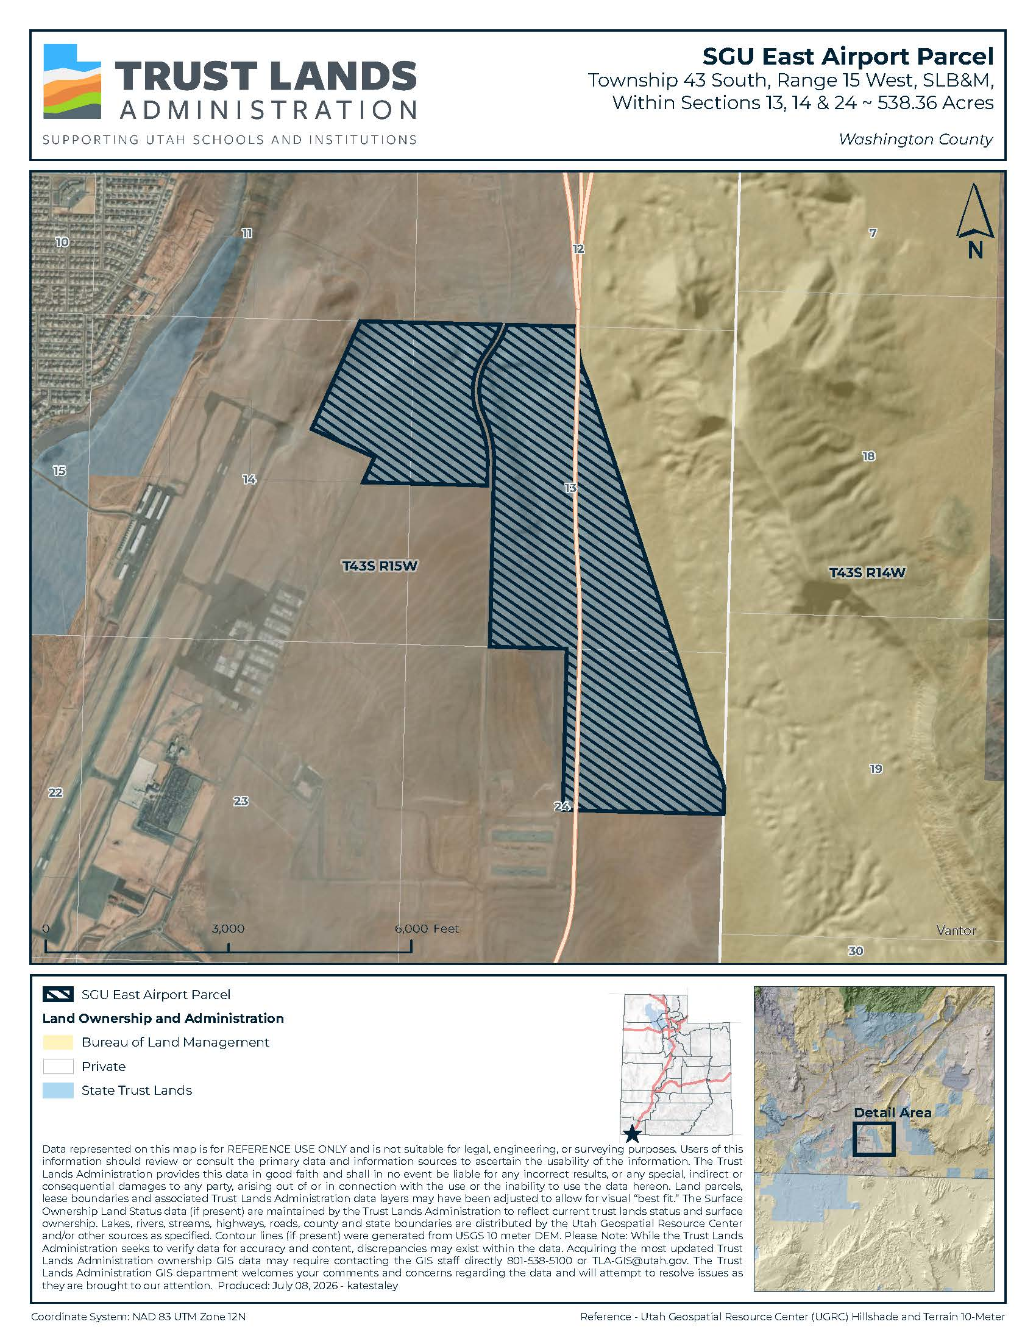
Exhibit B
St George Airport East Development Block
Parcel 1 – 485.10 Acres
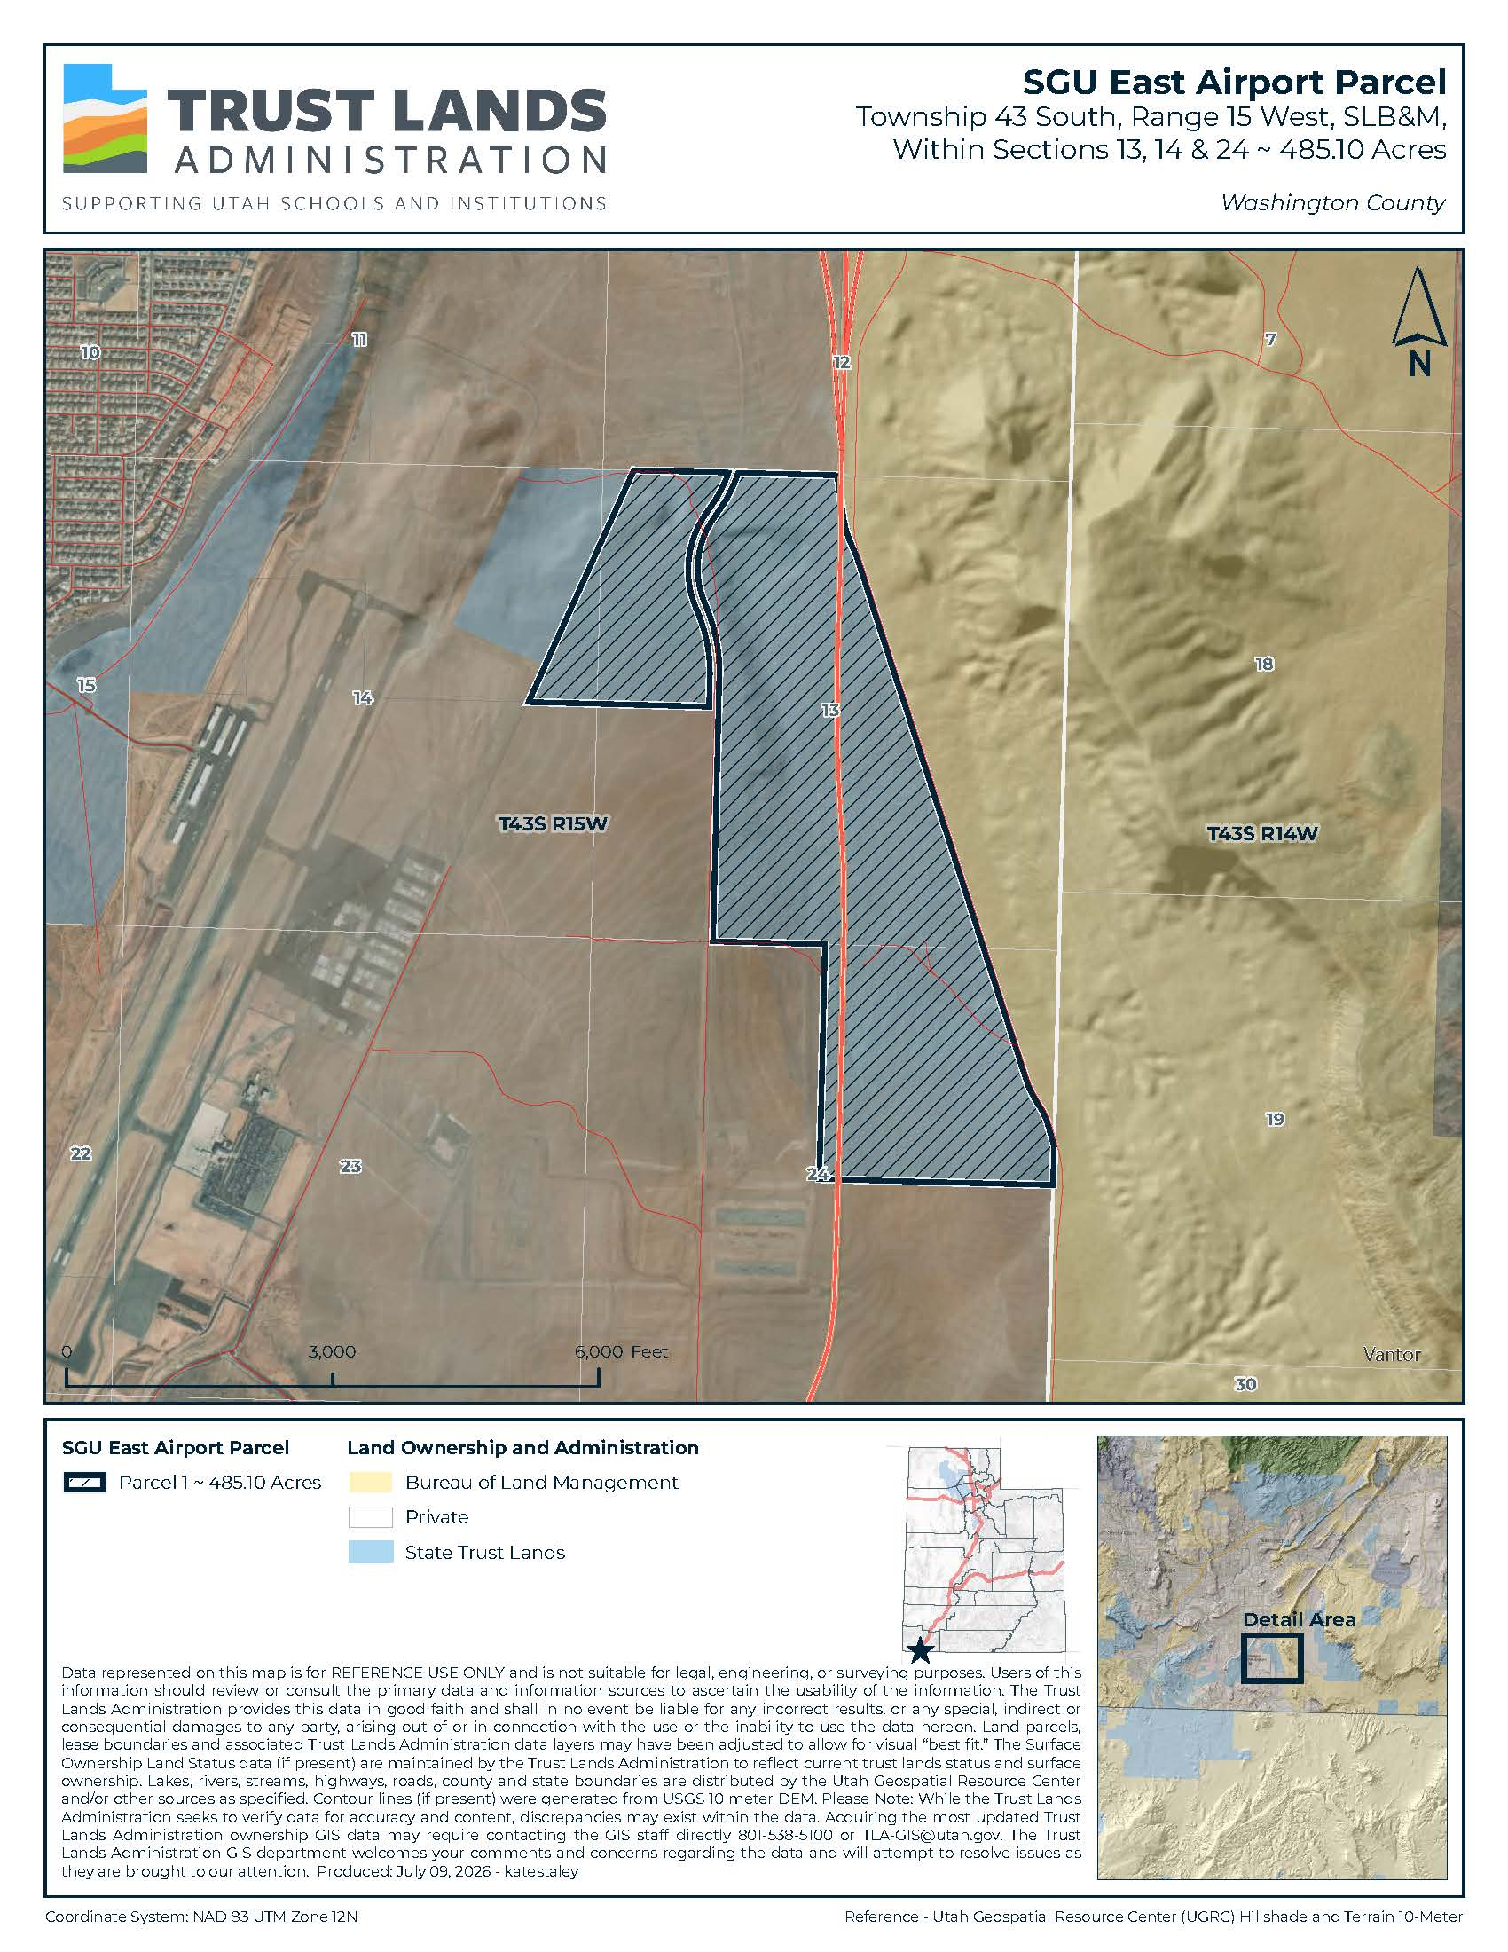
Exhibit C
St George Airport East Development Block
Parcel 2 – 53.26 Acres
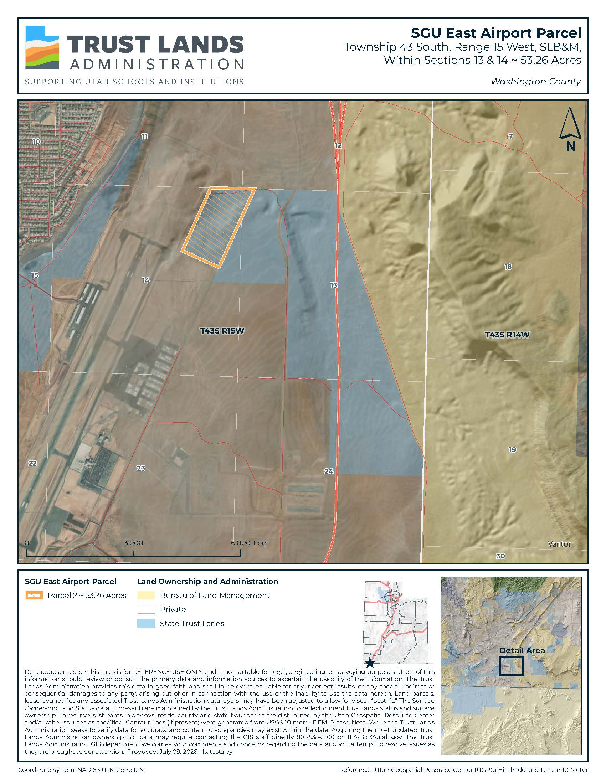
Exhibit D
St George Airport East Development Block
Existing Easements
