Real Estate Development

Land Offering

and

Request for Proposal

Pine Canyon

215 +/- Acres

Tooele County, Utah

5.5.25

**REQUEST FOR PROPOSAL**

**INTENT**

The State of Utah, School and Institutional Trust Lands Administration (“TLA”) has received interest in developing the Pine Canyon project (“project”), which is a 215 +\- acre parcel accessed from Droubay and Pine Canyon Roads (**see Exhibit A**). Considering this interest, TLA is soliciting other proposals for development and/or purchase of the parcel. Submitted proposals will allow TLA to ascertain the experience, vision, compensation structure, and resource commitment of developers interested in working with TLA on this project.

Proposals may be submitted for all or part of the project. TLA reserves the right to reject any offer. Preferred proposal formats include development lease or bulk purchase transactions, though all proposals will be evaluated upon their merits and benefits to the project’s Utah public-schools beneficiary. ***Substance in the response will carry more weight than form or manner of presentation.***

Compensation to TLA should reflect the level at which the developer intends to operate in selling finished lots or constructed homes. TLA desires to be compensated at a gross price point. TLA encourages additional and/or other compensation structures that could include performance-based bonus payment, profit participation, and/or percentage rents of revenue-producing improvements.

Brokers are encouraged to work with prospective clients to make them aware of this offering. TLA will not compensate brokers for their work; brokers must seek compensation from their client. Brokers will be required to submit a copy of their client agreement to represent their client during the selection process.

**REQUEST**

TLA requests proposals from developers to implement the project. In their proposals, developers are encouraged to state their qualifications, vision for their project, and any alternatives which may improve the developed project and TLA’s economic returns.

**EXPECTATION**

TLA anticipates the project will have high quality development that conforms to all governmental standards and requirements.

**TIMING**

TLA may or may not enter negotiations with one or more qualified developers, depending on the nature of proposals received. No set time frame has yet been established to develop the project, and no guarantees are made as to the timeframe of proposal approval.

**LAND OFFERING: PROPERTY INFORMATION**

The following information is provided for convenience and is not warranted by TLA. The developer should perform its own investigation regarding all aspects of the development requirements, including on- and off-site infrastructure.

**Location**

The Pine Canyon project is located in eastern Tooele Valley in Section 11, T3S, R4W, SLB&M. The property is north of Pine Canyon Road and east of Droubay Road (**see Exhibit A).**

**General Description**

The Pine Canyon parcel (parcel number 03-015-0-0047) is a contiguous 215 +/- acre block within Pine Canyon, less a +/- 1-acre pumphouse site for Lincoln Culinary Water Corporation. This property has an irregular shape and has not been subdivided. Proposals will be accepted for all or part of the property.

**Zoning**

The property is zoned RR-5 (**see Exhibit B).**

**Encumbrances (see Exhibit C)**

|  |  |  |  |
| --- | --- | --- | --- |
| **Contract #** | **Use** | **User** | **Term** |
| ESMT 2626 | 138kV Overhead Power Line | Pacificorp | Perpetual |
| ESMT 2448 | Water Line and Pumphouse Easement | Lincoln Culinary | Expires 2026 – *Sale Pending* |
| ESMT 2451 | 7.2kV Distribution Power Line | Pacificorp | Perpetual |
| GP 23482 | Grazing Permit | Michael L Dow | Expires 2036 |

**Access**

Public access to the parcel is currently located from Droubay and Pine Canyon Roads.

**Improvements**

The property has no improvements. The developer will be responsible for installing all development infrastructure, including roads, both on- and off-site.

**Utilities**

Developer should verify the actual locations and availability of all utilities.

**Water Rights**

Water rights may be available for purchase as a separate transaction.

**minerals**

Trust Lands Administration will retain the subsurface mineral estate by Utah Statute

**Property Condition**

The property is undeveloped land that has been used for seasonal livestock grazing and will not be improved further by TLA. Prospective developers are encouraged to visit the property and have permission to cross the property’s locked gate (Pine Canyon Road) and fence (Droubay Road).

**Parcel Availability**

Within TLA’s rules and procedures, the parcel is designated for development and is available for a transaction under the Planning and Development Group rules. Board approval and a cultural clearance will be required prior to development or sale of the property.

**Anticipated Use**

It is anticipated for this project to be a residential development.

|  |
| --- |
| Pine Canyon (215+/- Acres) Proposal Details |

|  |  |
| --- | --- |
| **SUBMIT SEALED PROPOSALS TO:** | Trust Lands Administration  Attn: Eric Baim |
| **ADDRESS:**  **EMAIL:** | 102 South 200 East, #600  Salt Lake City, UT 84111  ericbaim@utah.gov |
| **CLOSING FOR SUBMITTAL OF PROPOSALS:** | June 12th, 2025; 4:00 PM MDT |
| **ANTICIPATED BOARD APPROVAL REQUEST:** | October 2025 |
| **FURTHER INFORMATION:** | Eric Baim (801)538-5137  102 South 200 East, #600  Salt Lake City, UT 84111  [ericbaim@utah.gov](mailto:ericbaim@utah.gov) |

**TLA reserves the right to reject any and all proposals**

|  |
| --- |
| **Information for Respondents** |

1. **Proposals**

***Preferred Development Proposals:***

TLA requests proposals for the property outlined in the TLA Pine Canyon Land Offering enclosed in these documents. TLA may enter negotiations with one or more parties that submit proposals by the scheduled proposal closing. Acceptance of a proposal for the purpose of negotiations does not create an exclusive right or obligation to negotiate. Either party may terminate negotiations at any time in their sole discretion. Parties will not be bound to an agreement unless and until TLA has received final Board of Trustees approval and a written agreement has been signed by both parties.

1. **Compensation structures:**

While all proposals will be evaluated, TLA prefers the following transactional structures:

**Development Lease:**

TLA’s contribution to a development lease will be the subject lands. The proposing developer is expected to share proformas, profit sharing, anticipated construction costs, anticipated sales prices, percentage splits, anticipated absorption rates, etc. with TLA. The developer can propose either lot creation with vertical building packages, or bulk wholesale improved lots to select builders. Minimum returns to TLA must be guaranteed. In no circumstance will TLA authorize loans or liens on or against its lands while owned by TLA. Please state the percentage of gross selling price to TLA for the various product types. List the annual lease payment. Identify any other methods of compensation and timing that you propose.

**Direct Sale:**

Purchaser to clearly state the price per acre offered. This price must meet or exceed any appraised value. Please indicate whether this is a cash or financed offer and if a phased takedown is proposed. Purchasing the land in a phased take down may be considered, and proposals should outline the triggering factor(s) for the take downs. Additionally, a price escalator for unpurchased property must be defined for a phased take down approach.

**3) Developer Information:**

The proposing developer should provide a detailed description of their development experience.

A description of the developer’s resource commitment to the project is also requested. Any submitted financial information should be submitted separately from the RFP response with an accompanying claim for business confidentiality in the form detailed below.

**4) Form:**

**Electronic is preferred**:

Each development proposal shall be submitted in a sealed envelope or via email with a subject line bearing the words “Pine Canyon RFP”. Proposals submitted by sealed envelope must be marked on the outside of the envelope with the name of the respondent, their address, and telephone number. All proposals should include the information requested on the following proposal form, which is provided for convenience and not required for response. Any proposal should be complete when submitted. Provide additional information such as renderings, sketches, business plans, phasing, anticipated absorption rates, etc. with the proposal form as necessary. Each proposer may submit all forms electronically via email or flash drive. ***Substance in the response will carry more weight than form or manner of presentation.***

**Signatures**:

All proposals shall be signed and have the full address written in the appropriate spaces.

**Withdrawal**:

Any submitted proposal may be withdrawn at any time prior to the scheduled proposal closing time.

**Opening**:

Proposals will not be publicly opened.

***Document Forms:***

Document forms pertaining to the TLA Pine Canyon Offering may be obtained via the internet at <https://trustlands.utah.gov/work-with-us/real-estate-planning-development/>

**Confidentiality**:

Any information which needs to be kept confidential should be submitted separately with an accompanying claim for business confidentiality in the following form:

To the Director State of Utah, School and Institutional Trust Lands Administration:

I am making a claim for business confidentiality pursuant to U.C.A. §63G-2-309, for the attached document.

I make this claim based upon U.C.A. §63G-2-305(2): disclosure of the ______ [financial] information contained in the attached document/report would result in unfair competitive injury to my company because . . .

|  |
| --- |
| **Section 1.2: Proposal Form** |

**This Bid is Submitted To:** Trust Lands Administration

Attn: Eric Baim

102 South 200 East, #600

SLC, UT 84111

ericbaim@utah.gov

**Date: ______________________________________________**

**Business Name: ______________________________________________**

**Respondent Name: ______________________________________________**

**Title: ______________________________________________**

**Business Address: ______________________________________________**

**______________________________________________**

**Telephone Number: ______________________________________________**

**Email Address: ______________________________________________**

**Signature(s): ______________________________________________**

**Proposed Land Use(s):**

**Proposed Compensation Structure:**

|  |  |  |  |  |  |
| --- | --- | --- | --- | --- | --- |
| **Product Type** | **Acres** | **Gross Sales Price** | **SITLA %** | **SITLA Revenue** | **Other Applicable Terms** |
| **1)** |  |  |  |  |  |
| **2)** |  |  |  |  |  |
| **3)** |  |  |  |  |  |
| **4)** |  |  |  |  |  |
| **5)** |  |  |  |  |  |

Submitters may use this table, or their own if preferred. Additional pages and submittals will be accepted.

**Direct Sale Offer Price: ____________________**

**Additional Terms: ____________________________________________________________**

**Exhibit A: Location Map for Pine Canyon Project**

(TLA land shown in blue; BLM land shown in yellow)

**Exhibit B: Zoning Map for Pine Canyon Project**

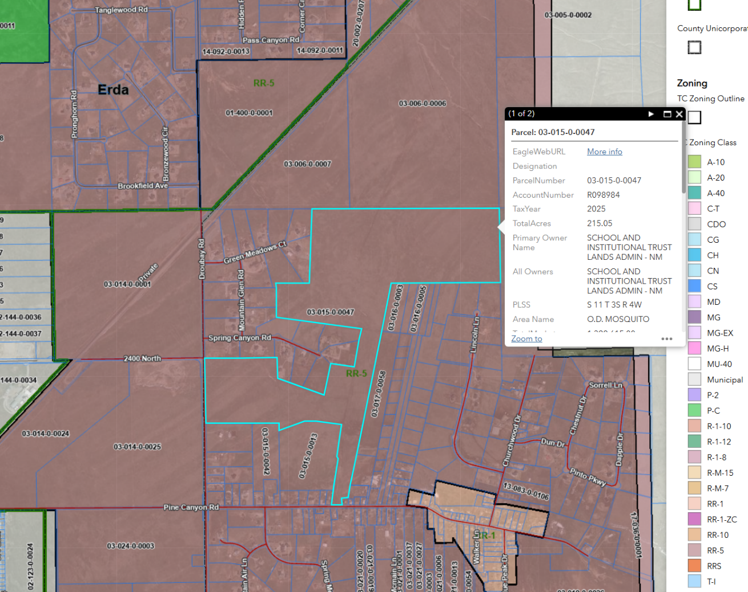

**Exhibit C: Encumbrances for Pine Canyon Project**

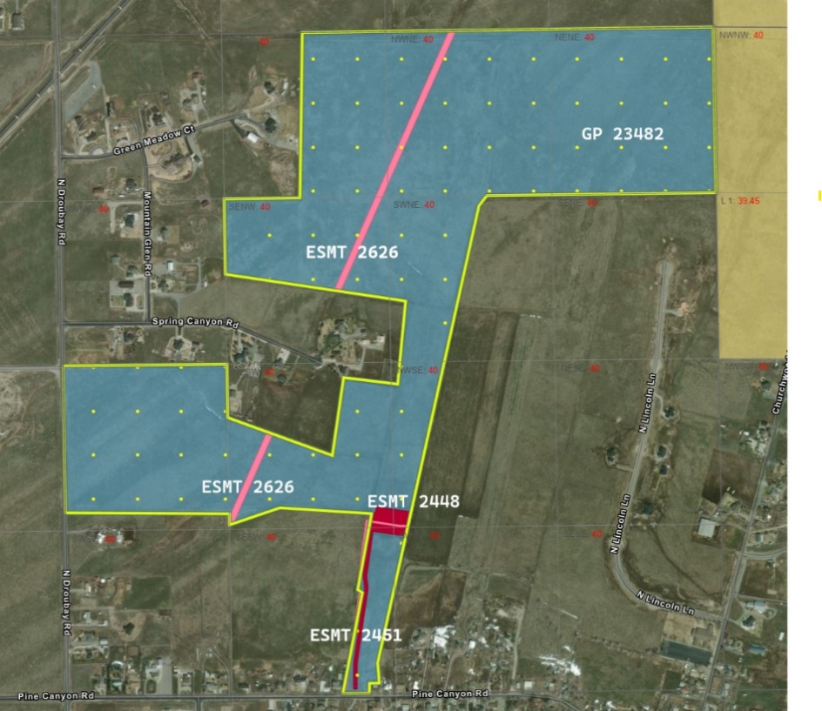

PUBLIC NOTICE: REQUEST FOR DEVELOPMENT PROPOSAL

Tooele Valley, Pine Canyon - The State of Utah School and Institutional Trust Lands Administration (TLA) has received interest in 215 +/- acres of property within Pine Canyon, Tooele Valley, Utah. TLA hereby gives public notice of this interest and is requesting proposals from any qualified parties. TLA’s property is located north of Pine Canyon Road and east of Droubay Road, in T3S R4W Section 11 SLB&M, Parcel # 03-015-0-0047. Proposals will be accepted by TLA until 4:00 PM MDT on June 12th, 2025. Please find details for submission at <https://trustlands.utah.gov/work-with-us/real-estate-planning-development/>

TLA Website Notice

**Tooele Valley Pine Canyon -** The State of Utah School and Institutional Trust Lands Administration (TLA) has received interest in 215 +/- acres of property within Pine Canyon, Tooele Valley, Utah. TLA hereby gives public notice of this interest and is requesting proposals from any qualified parties. TLA’s property is located north of Pine Canyon Road and east of Droubay Road, in T3S R4W Section 11 SLB&M, Parcel # 03-015-0-0047. No water is attached to this property.  Board approval and a cultural clearance survey will be required prior to development or sale.

Proposals will be accepted by TLA until 4:00 PM MDT on June 12th, 2025. Proposals should be mailed to TRUST LANDS ADMINISTRATION Attn: Eric Baim, 102 South 200 East Suite 600, SLC, UT 84111, (801)-538-5137 or email (preferred) to ericbaim@utah.gov. Reference: “Tooele Valley Pine Canyon.” Click here for the Full Tooele Pine Canyon RFP