102 South 200 East, Suite #600
Salt Lake City UT 84111
801-538-5100 Fax 801-355-0922
trustlands.utah.gov

Request For Proposal
for
400 acres of land
in two parcels
near Cannonville
Garfield County, Utah
February 27, 2024
REQUEST FOR PROPOSAL
The State of Utah, School and Institutional Trust Lands Administration (“Trust Lands Administration”) owns approximately 400 acres in two parcels near the town of Cannonville, in Garfield County, Utah. The Trust Lands Administration has received interest in developing the land and is requesting proposals for one or both parcels.
Property Description and Disclosures
The following information is not warranted by the Trust Lands Administration. It is provided for convenience only and may not represent the true condition of the parcels.
The proposer should perform its own investigation regarding all aspects of the parcel(s) including onsite and offsite infrastructure. The following information is considered reliable but not guaranteed.
Location: Within Section 32, Township 37 South, Range 2 West, Salt Lake Base & Meridian. See Exhibit 1 for the general location of the parcels and Exhibit 2 for a closer view:
  - Parcel A: N2NW4, SW4NW4, approximately 120 acres within Cannonville town limits.
  - Parcel B: SE4, SE4NE4, S2SW4, approximately 280 acres within Garfield County.
Access: Parcel A: County road.
Parcel B: None.
Condition: Unimproved. Redrock cliffs and sandy bench lands with native juniper-sage vegetation.
Entitlements: None.
Utilities: None.
Water: No water rights.
Minerals: Trust Lands Administration will retain the subsurface mineral estate by statute.
INTENT of Soliciation
The Trust Lands Administration is soliciting proposals for the lease and/or purchase of the lands to develop one or both parcels. Because of the parcel locations and their visibility from Highway-12, the Trust Lands Administration is interested in quality development including layout, building construction and landscaping. All submitted proposals will be evaluated for both direct revenue to the Trust Lands Administration and for the quality and viability of the development plans.
Substance in the response will carry more weight than form or manner of presentation.
TIMING
Proposals are due on or before 4 pm Mountain Time, Wednesday, March 20, 2024. The Trust Lands Administration anticipates identifying one or more parties for further negotiations by early May, 2024.
QUESTONS
Direct questions to Elise Erler: 801-538-5179 or eliseerler@utah.gov .
SUBMISSION REQUIREMENTS
Any proposer wishing to receive consideration should submit the following (substance in the response will carry more weight than form or manner of presentation):
A. Qualifications
- History: Provide background information such as a brief history of the developer, years in business and any other information communicating developer’s capabilities to execute a project.
- Relevant Developer/Builder/ Business Experience: An overview of residential, hospitality and/or commercial business experience over the last 10 years.
- References: Contact information for at least 3 current or recent-past references to demonstrate general professional integrity and reputation of the buyer.
B. Statement of Interest
- Vision: Summarize developer’s vision for the parcel(s). Drawings and/or plans may be submitted to support the respondent’s vision; however, the respondent is not required to submit any plans or drawings.
- Financing: Financing plan for parcel lease and/or purchase and construction.
- Compensation: Proposed lease and/or purchase price.
- Other Information: Identify and discuss any other information that you believe the Trust Lands Administration should be aware of or should take into consideration when reviewing your submission.

SUBMISSION INFORMATION
Date and Time: By 4:00 pm Mountain Time on Wednesday, March 20, 2024; no exceptions.
Format: Electronic file (PDF preferred).
Proprietary financial information: Should be labeled “Confidential” and submitted in a separate electronic file that includes a request for Business Confidentiality as described in Exhibit 3.
Submission Method: Electronic: eliseerler@utah.gov .
Reference: “Cannonville Property.”
The Trust Lands Administration reserves the right to reject any proposal.

Exhibit 1
General Depiction of the Cannonville Area and Location of the Parcels
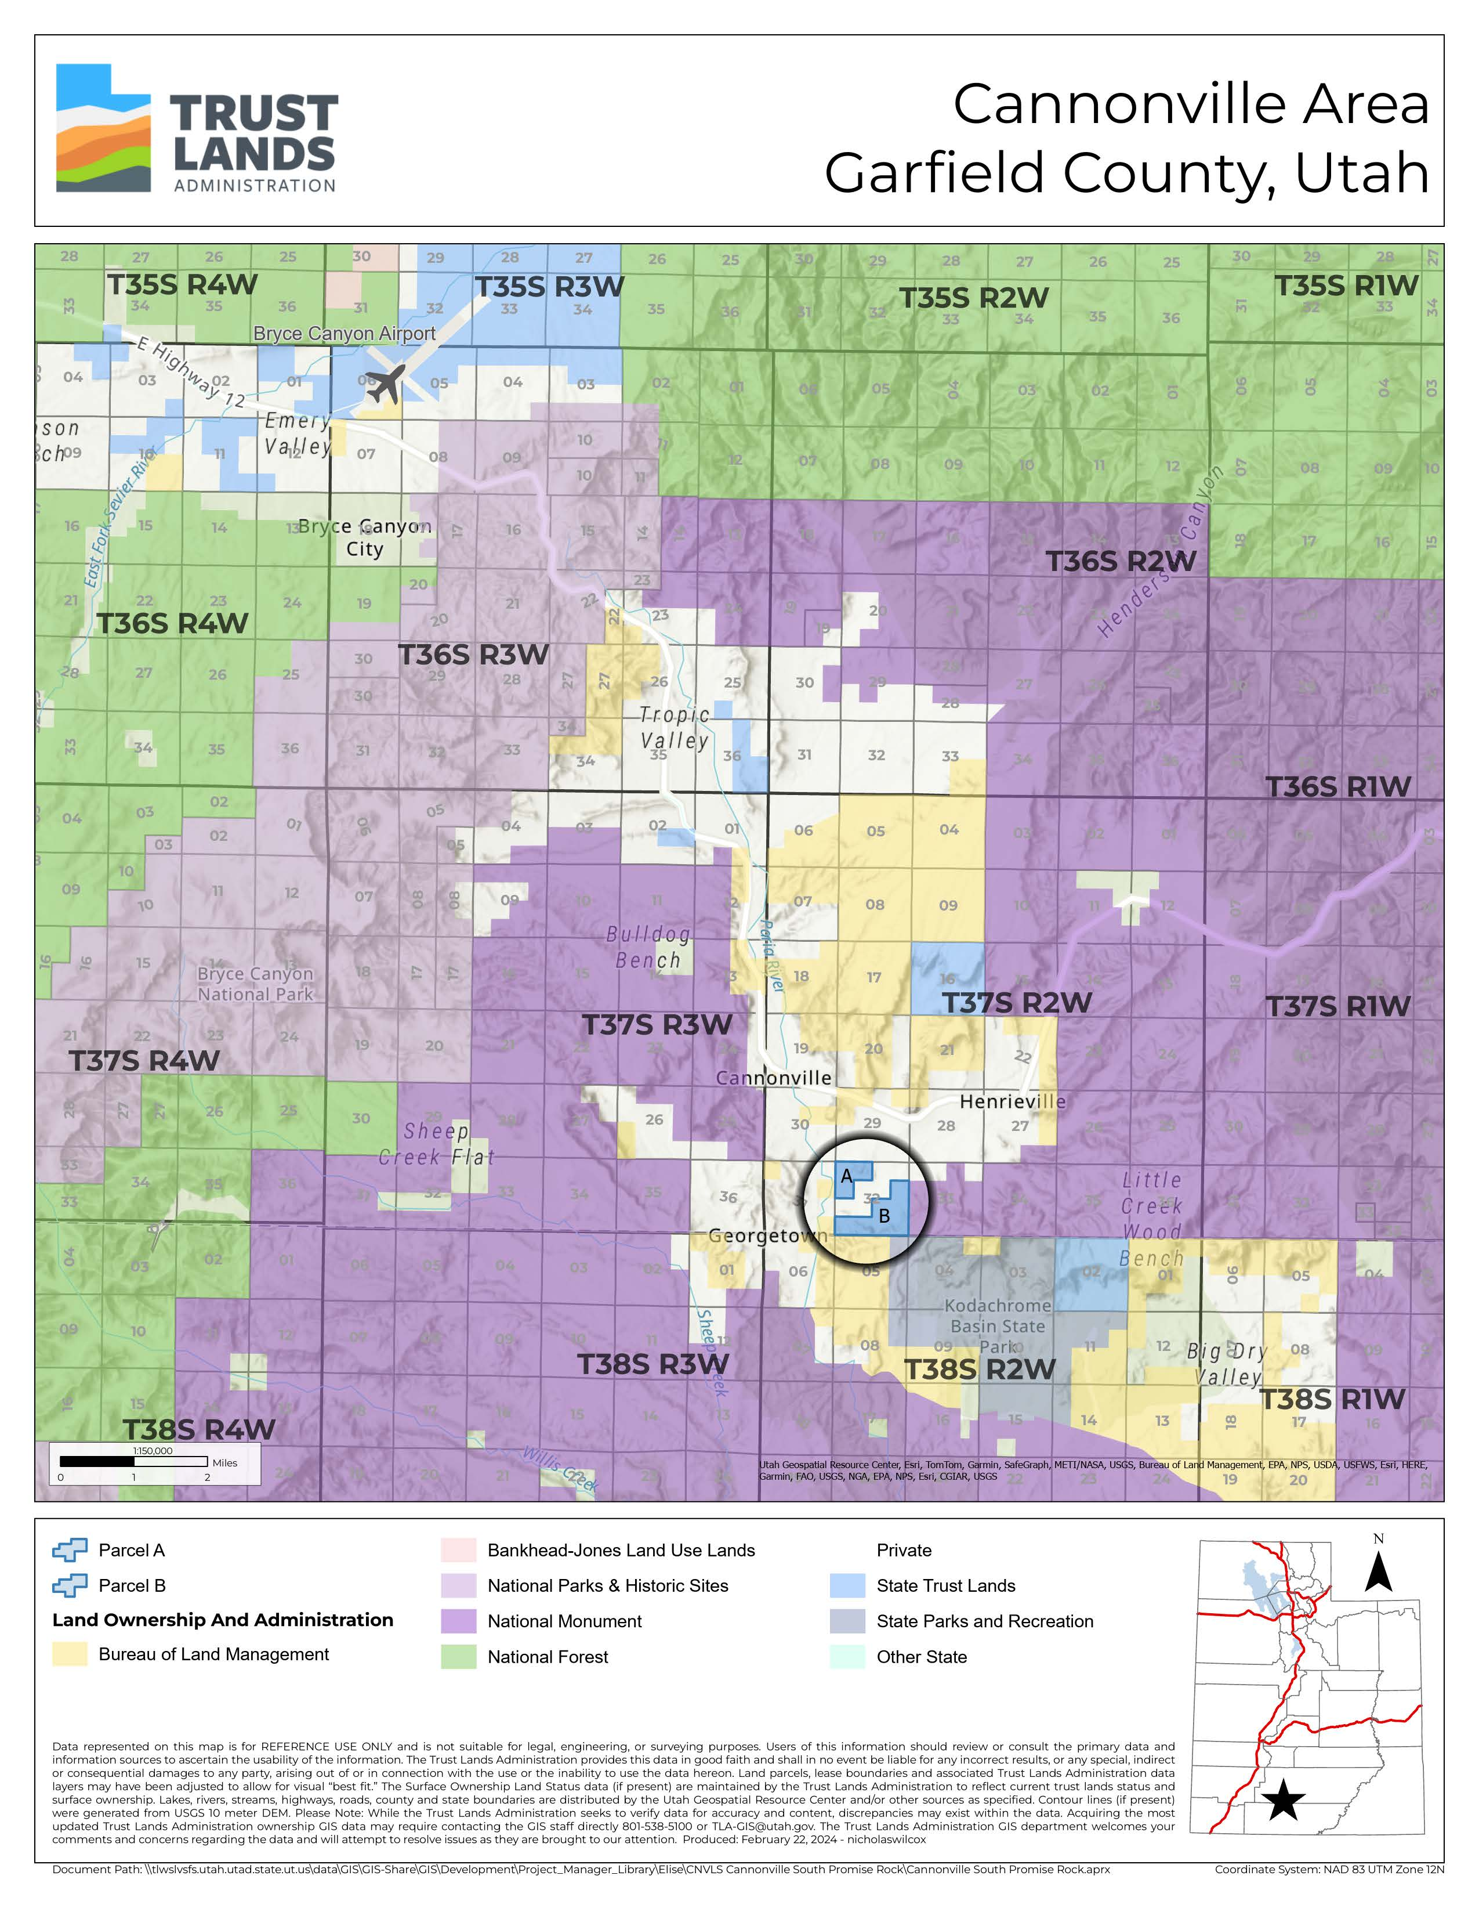
Exhibit 2
General Depiction of Parcels A and B
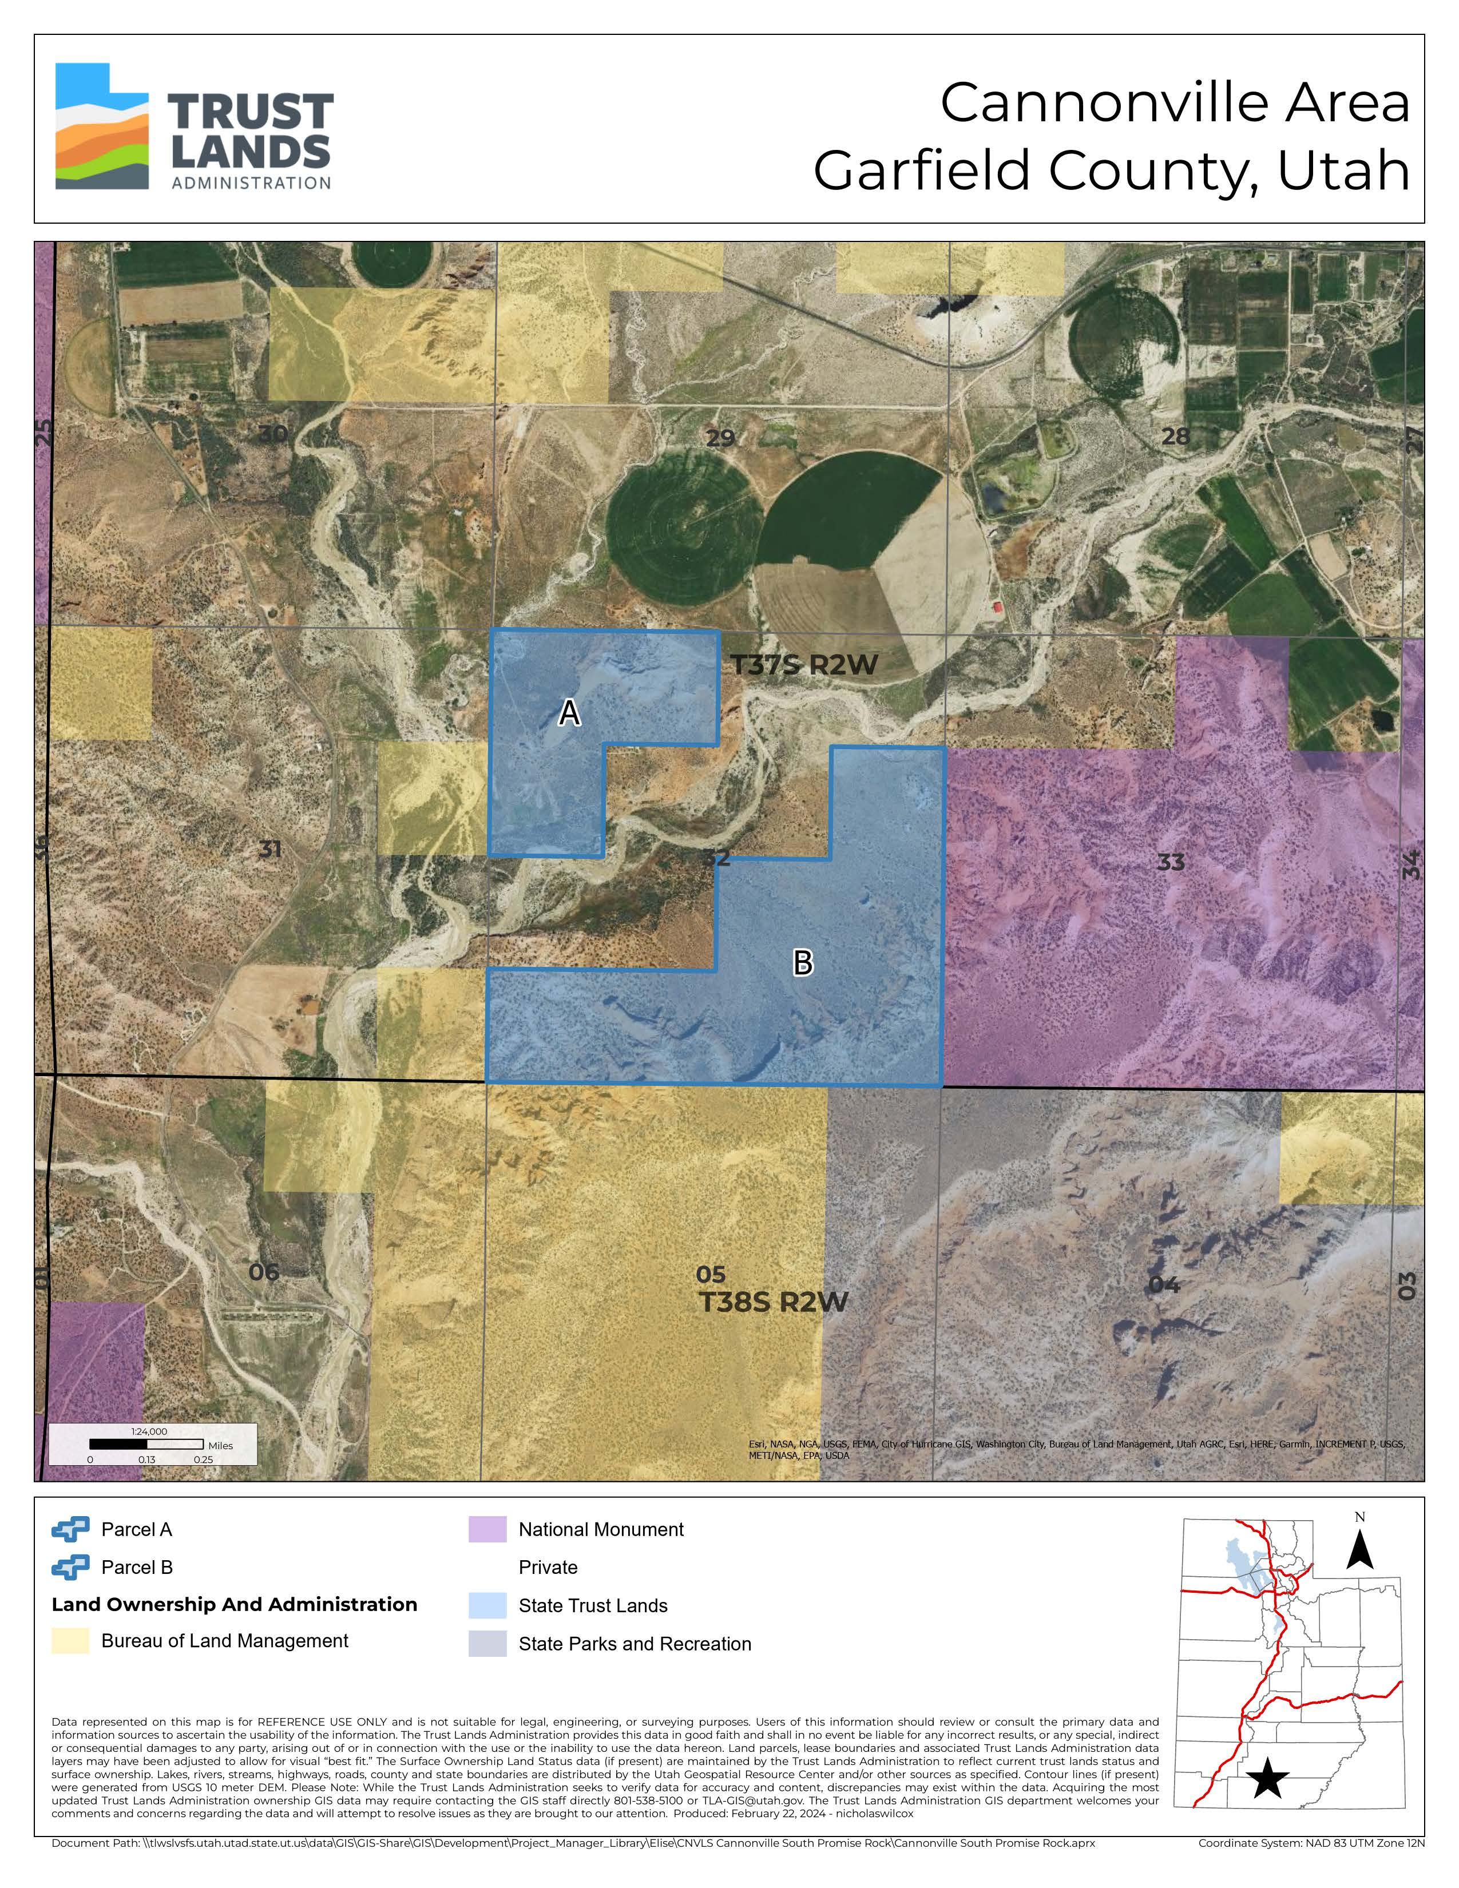
Exhibit 3
CLAIM FOR BUSINESS CONFIDENTIALITY
Pursuant to and in accordance with Utah Administrative Code ßR850-6-500(3), a person or entity doing business with the State of Utah, School and Institutional Trust Lands Administration (TLA) has the right to make a claim for Business Confidentiality for records, documents, data or other information provided to TLA during the course of business if the records, documents, data or other information conform to Utah Code Annotated §§63G-2-305(1) and (2).
Claims of business confidentiality must conform with U.C.A. §63G-2-309 Confidentiality claims.
A claim of business confidentiality must be submitted at the same time as, and attached to, the records, documents, data or other information for which the claim is being made. It cannot be submitted separately, in advance, or after the fact.
If the records, documents, data or other information requested to be treated as confidential do not meet the criteria found in U.C.A. §63G-2-305 and §63G- 2-309, TLA may not be able to withhold such records, documents, data or other in the event of a request for records under the Government Records Access and Management Act (GRAMA).
To make a claim for business confidentiality, please direct such request to the Executive Director of TLA and include:
1. A written claim of business confidentiality; and
2. A concise statement of reasons supporting the claim of business confidentiality.

